Manual Unit Testing

eHealth Database – chatmessages

Doctor Point of View

1. Once logged in, the Doctor can view their Patient List. In order to chat with someone, they must click the SELECT button next to their details.

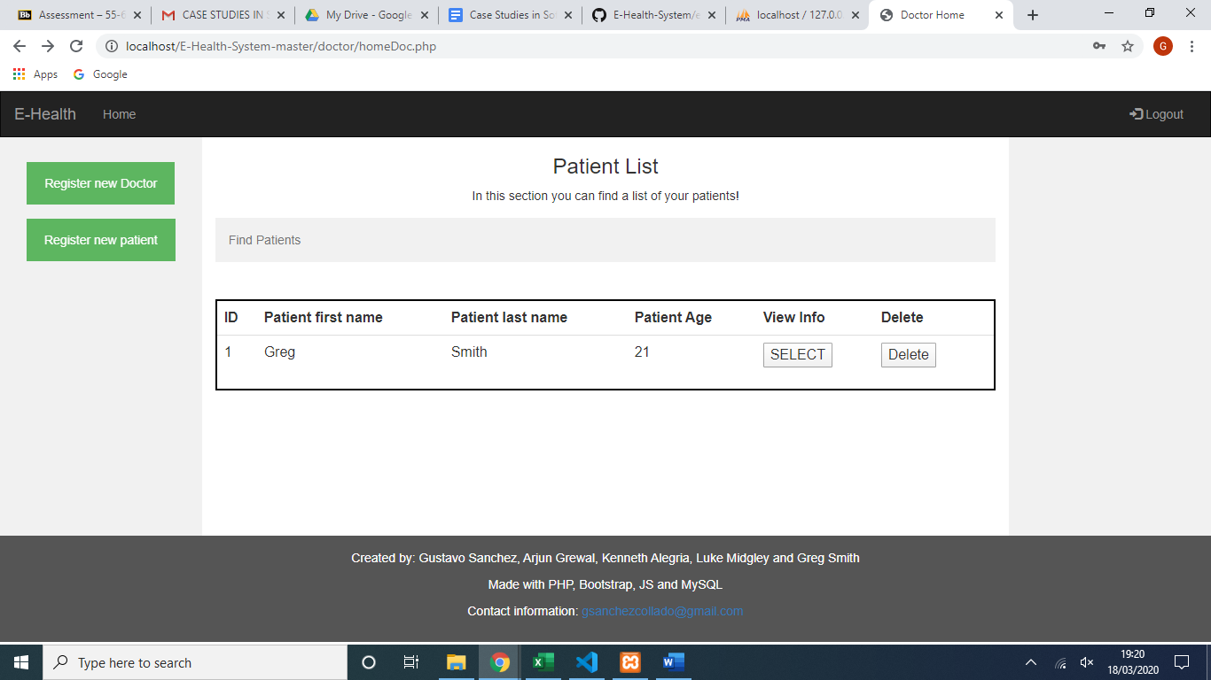

1. 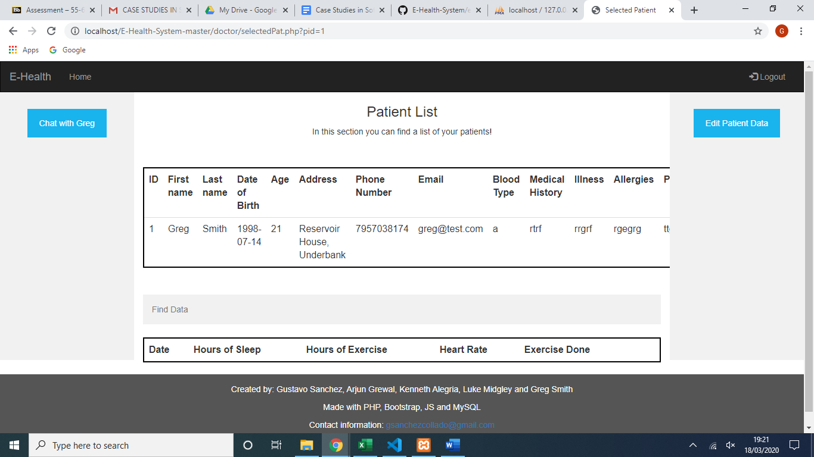Once SELECT has been clicked, the doctor is taken to that individual patient’s main page. Here they can select chat in the column on the left side of the screen.
2. This opens a chat dialogue with that patient.
3. 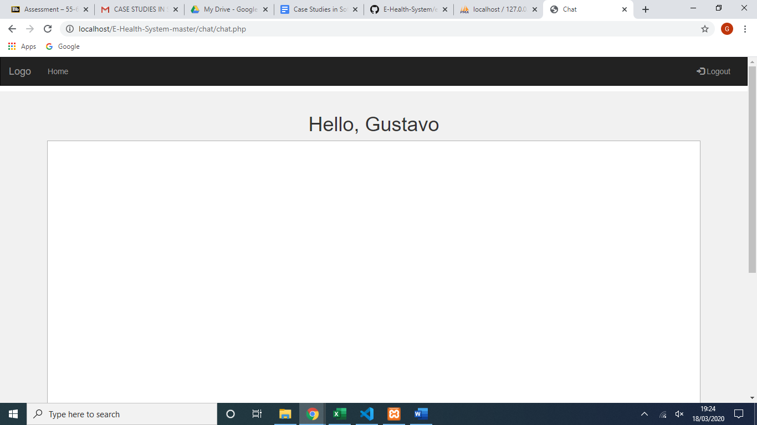A message can be entered by the Doctor, this is then sent to the recipient.
4. 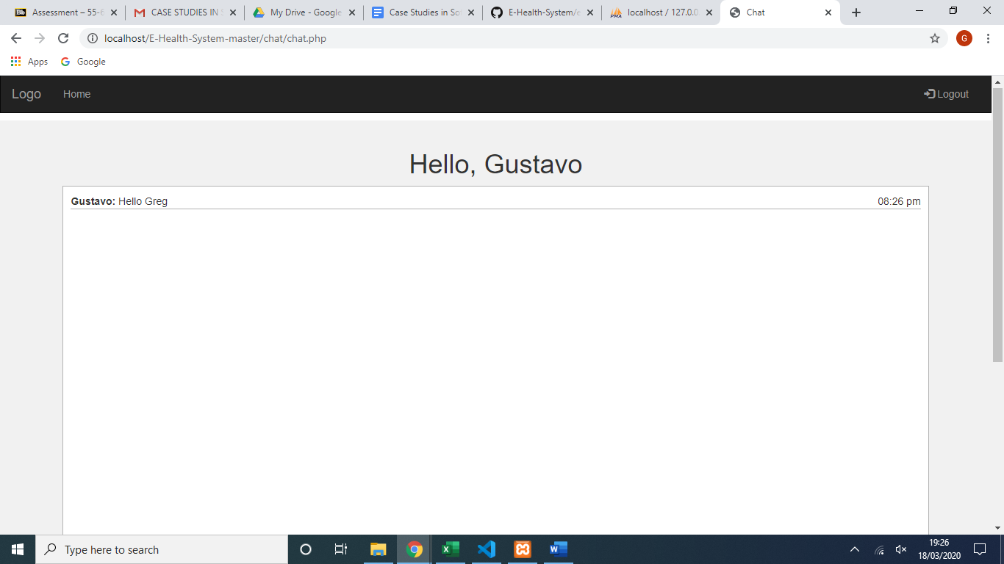This message is then stored in the chatmessages table as part of the eHealth database.

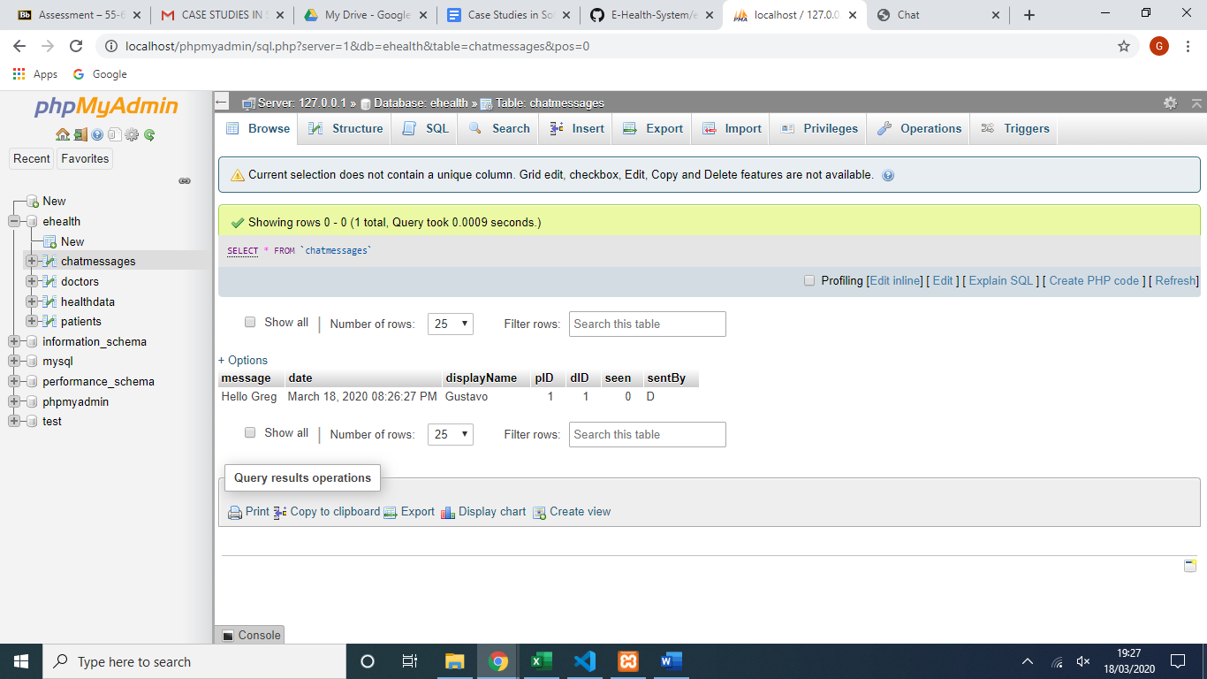

Patient Point of View

1. After the patient who has been sent the message logs into their account, they can click chat.
2. 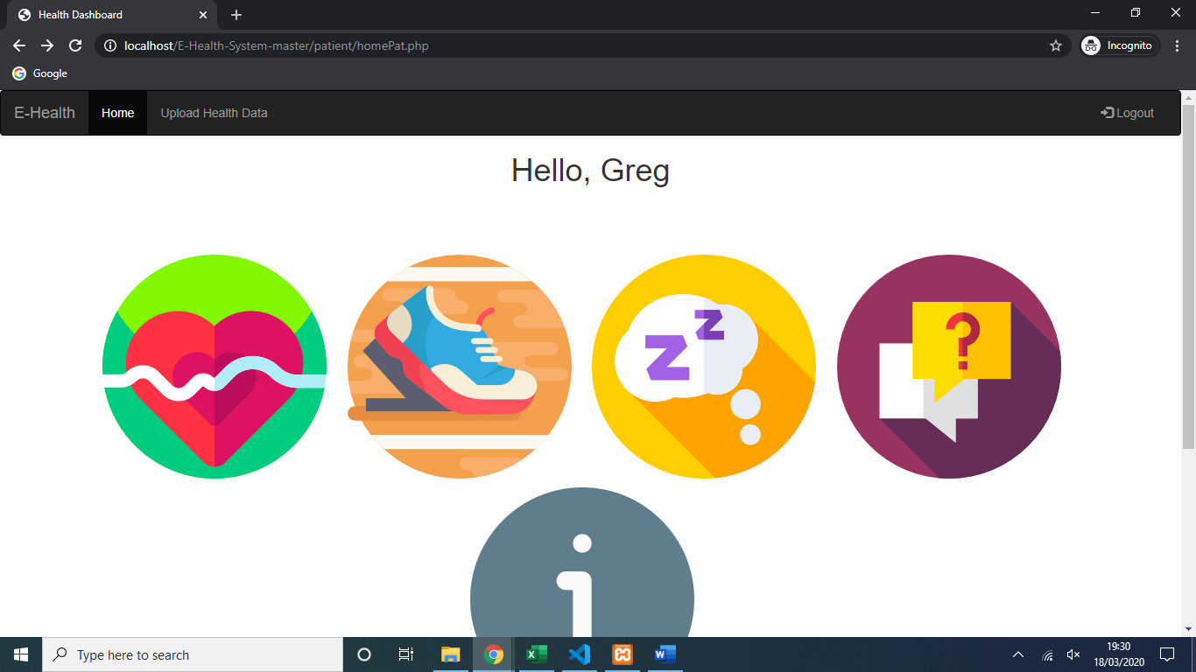When they click this icon the same chat dialogue box is opened, and they can see the message sent from their Doctor.
3. 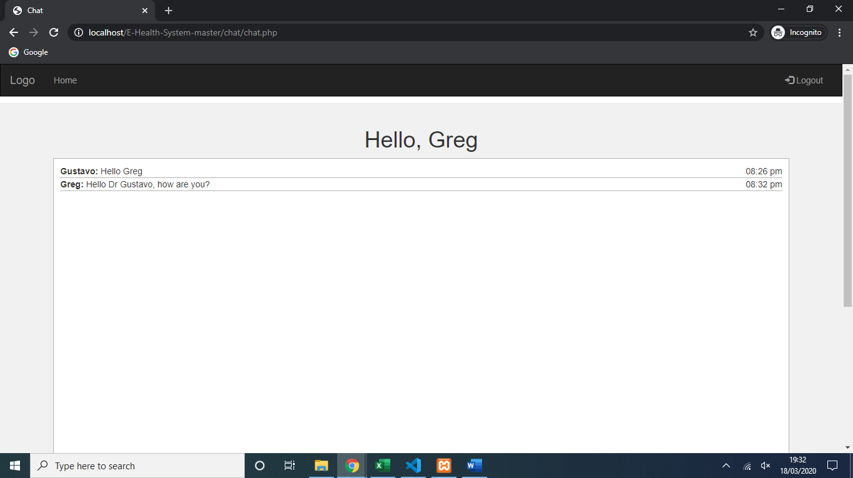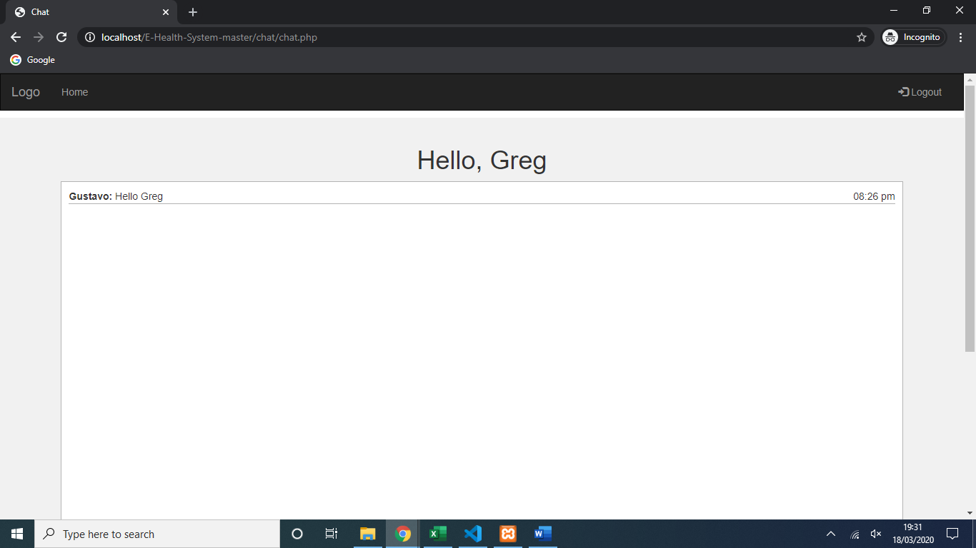A message can then be sent in reply to the Doctor.
4. This return message is then also stored in the chatmessages database table.
5. 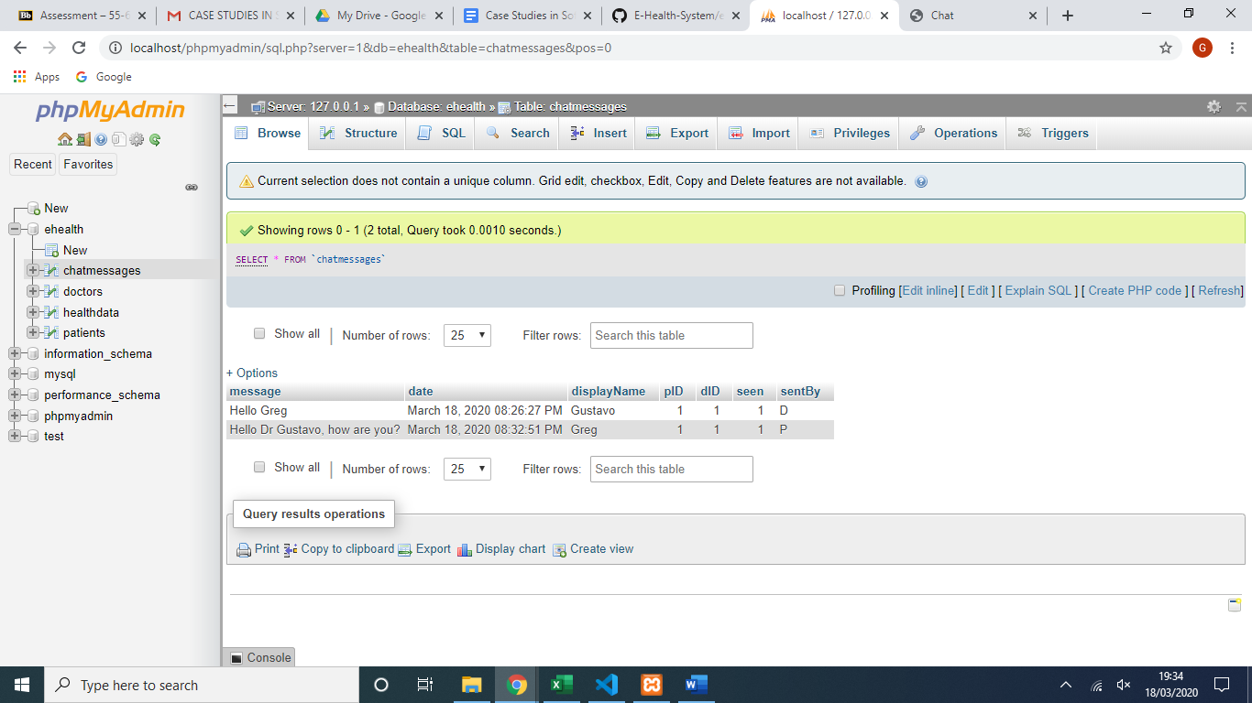This message is then delivered straight to the Doctor without having to refresh the page.

